

SSA Global™
Professional Services Organization
Statement of Work
For
Andin International, Inc.

Project: Materials Management Implementation and Installation of Infinium Web User Interface

Client: Andin International, Inc.
Dated: October 6, 2006
Sales Executive: John Deignan
Prepared by: Kit Thomason

SSA Global Technologies™, Inc.

Table of Contents

Introduction 3
Complete Agreement 3
Expiration 3
Scope of Services 4
Project Overview 4
Project Scope 5
Assumptions 7
Client Involvement 9
Client Responsibilities and Prerequisites 9
Support and Maintenance 9
Custom Programming 10
Changes in Scope 11
Fee for Services 11
Period of Performance 12
Location of Performance 12
Contact Information 13
Client Owner (SSA Global PSO Practice Director): 13
Client Project Contact 13
Client Management Contact 13
Client Billing Address 13
Signatures 14
Statement of Work Approval 14
Document ID: ANDIN10062006A 14

Introduction
SSA Global Professional Services Organization (PSO) will provide assistance to Andin International, Inc. (Client) in completing the project Materials Management Implementation and installation of Infinium Web User Interface (Project) according to the terms outlined in this Statement of Work (SOW).

Complete Agreement
This SOW, in conjunction with a signed Professional Services Agreement comprises the total agreement for the described level of effort. Upon execution of this statement, SSA Global will provide the services in the time frame described in the Project Schedule.
If there are any unforeseen delays in the execution of these documents, the Scope of Services and/or Period of Performance may be adjusted based on mutually agreed upon terms between SSA Global and the Client.

Expiration
Until executed by the Client and received by SSA Global, this addendum shall act as a quotation for services that will expire thirty (30) days from the date of issue. Any extensions to this term must be made in writing by SSA Global.

Scope of Services
This SOW reflects SSA Global’s understanding of the priorities established by the Client.

Project Overview
This is a new implementation of the following SSA Global applications:
- SSA Infinium Materials Management: Purchasing Management (including Cross Applications, Journal Processor, Payables Exchange)

- SSA Infinium Web User Interface

Services related to the implementation of the above SSA Global applications are considered to be in scope for this project.
As a guideline, the project will follow the following methodology. SSA Global Professional Services Consultants will partner with the Client project team members to provide application and technical expertise and project management to expedite and ensure the quality of the implementation process. The Client will implement in a centralized environment (applications on one AS/400 centrally located). The four major steps of this methodology are:
- Step 1 - Project Initiation and Planning
- Step 2 - Solution Design and Validation
- Step 3 - Solution Development
- Step 4 - Production Rollout
These steps will apply for each application area. The detail deliverables and project scope will be determined during the Project Planning setup.

Project Scope
Outlined below is a high-level definition of the project scope and related deliverables. This scope will be reconfirmed during the initial Project Planning Workshop and may be modified during the implementation phase through change management.

SSA Infinium Purchase Management (includes Cross Applications, Journal Processor, and Payables Exchange

- SSA Global will lead the project team in identifying business and reporting requirements for Purchase Management
- SSA Global will facilitate a Business Requirements Workshop with project team
- SSA Global will provide on-site training for the Purchasing, Journal Processor, Payables Exchange, and Cross Applications.
- Assist with the control file set up
- Assist in the creation of a prototype environment to test and validate decisions made in the test environment.
- Identify accounting requirements for account number resolution and accounting transactions (JP). Client will be trained in JP and will be assisted with initial setup. Complete and final setup of all transactions will be client’s responsibility.
- No purchasing history or PO details will be converted
- No modifications to the Requisition or PO forms are included in scope. Minor tweaking to standard requisition or PO forms will be included.

SSA Infinium Web User Interface:

SSA Global will participate as follows:

- Verify IBM Websphere Application Server configuration
- Install, configure and test the SSA Infinium components.
- Client is responsible for installing Web sphere Application Server.
- Assist with the production cutover planning and go-live

Assumptions
- This proposal is based upon Client hardware availability with adequate capacity throughout the project.
- Client will be responsible for all hardware, networking, and communication issues
- Client will provide a Project Manager who will be able to devote at least 50 percent of his/her time for this portion of the implementation. SSA Global will provide an advisory-level Project Management resource for this portion of the implementation project. SSA Global will work in a joint capacity with the Client Project Manager to influence resource coordination, communication and issue escalation processes.
- Client Functional Managers/Staff will be assigned to the project team. SSA Global will blend their resources to supplement and assist the Client project team resources. In some cases, multiple roles may be filled by one resource and/or multiple resources may fill one role.
- With the specific exception of installation activities for the Web Application, all other technical deliverables are the responsibility of Client. SSA Global will provide program design, coding, and testing assistance on those specific items outlined per this Statement of Work.
- The Client project team will be responsible for testing, validation, and sign-off of the data and deliverables.
- The services provided by SSA Global under this Agreement are being performed on a time and materials basis and are subject to change based on additional information gathered during the course of the project. The number of hours quoted represent SSA Global’ best estimate based upon the information available at this time and is subject to change. Should any additional services be required to complete this project, and Client retains SSA Global, such services shall be provided for and billed on a time and materials basis.
- In order to reduce the risk of exceeding the implementation estimate, a Change Management process will be defined and adhered to during this project. Should any additional services be required to complete this project, an estimate of such services shall be submitted in writing to Client for approval prior to scheduling of the consultants. SSA Global Project Manager is obligated to notify Client, in writing, when any significant step is exceeding the estimates by a material amount (over 10%). This notification will be a Change Control form requiring client signature before additional work is performed.
- The estimate of days of assistance for the activities detailed in this proposal are to supplement the Client project team involvement and are not a total number of days required for the completion of an activity. Any additional time that is required to complete an activity outlined in this proposal is the responsibility of the Client resources.
- A consulting day is defined as an eight-hour workday and can be performed on-site or off-site (i.e., remote document preparation). The estimates are in days however the time will be billed on an hourly basis.
- Travel and living expenses will be billed separately and are to be paid by Client.
- Client will be responsible for maintenance of any services or modifications provided under this Agreement. In the event Client wishes to retain SSA Global to provide services relating to the maintenance of any such services or modification, this service may be provided on a time and materials basis at SSA Global’s then-current standard rates.
- This Agreement is considered confidential and is not to be disclosed to any entity other than Client.
- Billable services will be provided at the rates shown on the accompanying “Fee for Services” – see below.

On-Site Training
- On-site training class size is limited to 12 participants with a minimum of one computer per two participants. A workstation with an LCD projection system will be provided for the instructor.
- Training workshops will be performed over the standard SSA Global training database or customer’s database as determined by the project team. If training is performed using the customer provided database, be mindful that participants may be exposed to confidential information. Four training guides will be sent for onsite training. Additional training guides are the responsibility of the client.
- The Client will provide an on-site training facility, hardware/software and networking.
.

Schedule of Deliverables
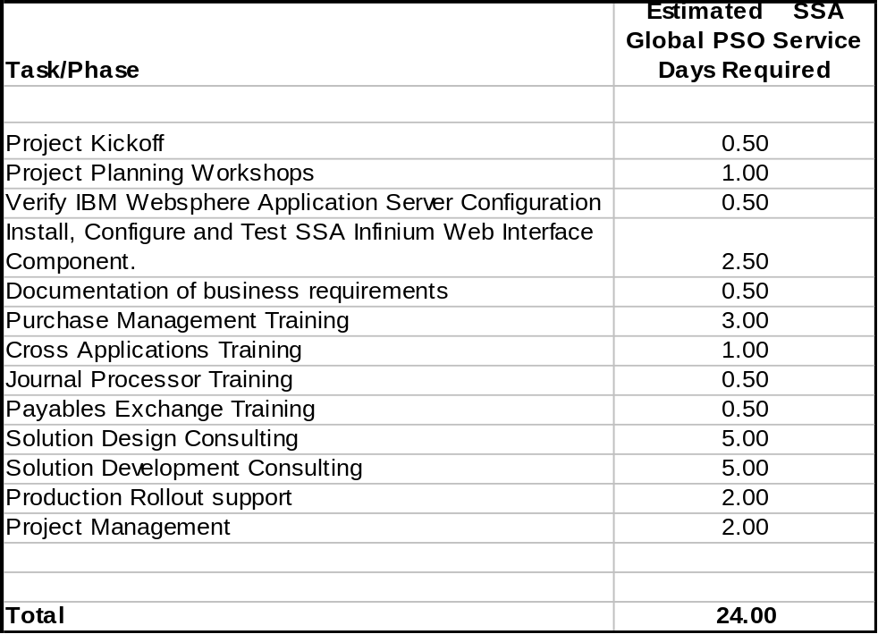

Client Involvement
The nature of the Project requires participation from Client teams as set forth herein. The requirements analysis, specification and project planning steps require considerable Client involvement in setting Project priorities and schedules for developing the readiness testing criteria and determining the user training requirements and developing a training plan. The Testing and Final Steps will also require involvement from both the Client team assigned to the Project as well as Client’s end-user community. Unavailability of Client team personnel has the potential of negatively impacting phase completion and schedule compliance, as well as interruptions in delivery of a Project with reasonable quality assurance.

Client Responsibilities and Prerequisites
It is agreed that Client will make the following available to the SSA Global consultants during the term of the engagement. Failure to meet any prerequisite could result in delays in meeting the Client’s schedule requirements and additional on-site charge.
- Client must have installed and operational all necessary supporting hardware and software at supported release levels including network interfaces.
- Timely availability of key Client staff members who can provide necessary skills and accurate and complete information for their portion(s) of the Project and who will support the Project as described herein and as otherwise deemed necessary.
- Timely availability of and access to all Project required computer systems, as well as logins and passwords with sufficient authority to accomplish the tasks described in the Schedule of Deliverables.
- Timely availability of any office services relevant to the delivery of these services (e.g. telephone, office supplies, copying capabilities, etc.) and adequate facilities for a project work area and meeting area.

Support and Maintenance
In the event that Client is a licensee of SSA Global software requiring routine support and maintenance services, the services described and to be provided as part of this SOW supporting implementation of such software shall not address, and shall not be interpreted to include, any of such support and maintenance services which SSA Global routinely provides as part of its software warranty under an Order Form and License Agreement. Should Client request that SSA Global provide on-site or other services as part of support and maintenance, SSA Global’s agreement to provide such on-site services shall depend upon, and only be made available to Client under, a separate Statement of Work and for an additional payment based upon the description of the services to be performed.

Custom Programming
Custom programming includes detailed design, programming, unit test and project management. Installation is not included unless specifically stated in the scope of services herein. If included, installation may assume modification work will be sent via system communication. Installation on AS/400 systems does not include menu master set up and compiling of files and programs on your system unless specifically stated.
SSA Global understands Project Management to be an integral part of the overall success of a project. Project Management includes quality assurance, systems test, internal project organization, client communication and feedback, and technical documentation coordination. Quality assurance included in Project Management provides for a reasonable amount of testing to be done on all work. We expect the Client to test all enhancements and modifications once installed on their system in a test environment to insure complete customer satisfaction prior to placing the modification into production.
While we strive to provide our clients with the most error free code possible, unforeseen problems may be discovered when testing is done in the Client's environment.
Specification changes made after approval of this Statement of Work may require a change in scope amendment. See “Changes in Scope” section.
If errors are found 30 days or more after the delivery of the software, all work will require a “Changes in Scope” amendment or a new Statement of Work.

Changes in Scope
If the Client attempts to introduce different goals or principles based upon new factors introduced or discovered by the teams, including, but not limited to, the type of work to be done, amount of hours or work to be performed, the time schedule estimated, or a change in management direction affecting the scope of the Project, or any other changes in direction, priority, schedule or approach once established and agreed to in this SOW, such changes must be requested in writing by Client. Such changes will necessarily have both a schedule and cost impact on the Project and these changes will not be binding upon SSA Global unless SSA Global shall have received both an equitable price and schedule adjustment. Any change in Project scope must be addressed in writing and will amend this SOW.

Fee for Services
Based on the Project scope, deliverables identified, and estimated hours to complete the Project, SSA Global provides the following time estimates. These estimates, for the Project, are not to be considered a fixed bid or not-to-exceed. As described earlier all changes in scope will require revised time estimates and Client approval to implement.
Labor Category |  | # of Days | Hourly Rate | Estimate
SSA Global Project Management |  | 2 | $1600 | $3,200.00
SSA Global Professional Application /Technical Consulting Services |  | 17 | $1500 | $25,500.00
SSA Global On-site education |  | 5 | $2000 | $10,000.00
Consulting Estimate Subtotal |  | 24 | USD | $38,700.00

Payment Schedule
The estimated fees payable for the consulting services effort defined within this statement of work are US $38,700. This fee is a time and materials estimate and not considered to be a fixed bid.
This SOW is based upon the information supplied to SSA Global by Client and if there is a variation in this information, then the costs associated with the project may have to be recalculated.
The fees have been calculated based on a standard eight-hour work day, Monday to Friday. Should it be necessary for work to be performed in addition to these hours, then further charges may be incurred.
Client agrees that they may be liable to pay SSA Global for services or the cost of any re-work where SSA Global is delayed or prevented from providing services because of a failure of Client to meet mutually agreed upon obligations. SSA Global agrees to use reasonable efforts to re-deploy personnel to mitigate any such amount payable by Client to SSA Global.
Invoices for Consulting Services are mailed weekly for hours worked and travel expenses during that period. Net amount is due upon receipt of invoice.
Invoicing of work on the engagement will be on a Time and Materials basis. All sign-offs related to milestones or deliverables are to allow the engagement to proceed to the next milestone or deliverable. Invoicing and payment will not be contingent upon the sign-off of milestones or deliverables.

Note: In the case of professional services to be provided at Client’s facilities, the fees set forth in this Agreement do not include out-of-pocket expenses (such as transportation, lodging, meal, and other expenses) incurred by SSA Global while providing the services ordered, which expenses will be charged to Client from time to time or upon completion of the ordered services. If performance of the services is delayed due to Client’s failure to provide required access or personnel or similar reasons or canceled with less than seven (7) days notice once ordered by Client, Client shall pay SSA Global’s then prevailing daily charge, plus reimbursement of all such out of pocket expenses, for each day for each person assigned by SSA Global to provide the services.

Period of Performance
The period of performance for this Project will commence within two weeks of Client and SSA GLOBAL’s execution of this SOW. The planned and actual start and end dates will be established by mutual agreement between Client and SSA Global.
The SSA Global consultant(s) involved in this Project will work the same daily hours as the Client’s employees associated with the Project. SSA Global expects the workday to consist of eight (8) hours with one (1) hour for lunch. Additional time beyond eight (8) hours a day or forty (40) hours a week must be pre-approved by the SSA Global Project Manager.

Location of Performance
Professional services will be provided at the SSA Global facilities, the facilities of SSA Global’s subcontractors and/or at the Client’s facilities.

Contact Information

Client Owner (SSA Global PSO Practice Director):
Jeffrey Meyers

301-293-4189
Jeffrey.meyers@infor.com

Client Project Contact
Mike Larkin
212-886-6148
mlarkin@andin.com

Client Management Contact
John Esposito
212-886-6117
Email: jesposito@andin.com

Client Billing Address
Andin International, Inc.
609 Greenwich St.
New York, NY
10014
USA

 |  |  |  |  |  |  | ENGAGEMENT AUTHORIZATION
 |  |  |  |  |  |  | Contract #: |  |  |  |  |  |  |  |  |  |  | ANDIN10062006A
 |  |  |  |  |  |  | Accompanying SOW#: |  |  |  |  |  |  |  |  |  |  | ANDIN1006262006A
CUSTOMER INFORMATION
Company Name; |  |  |  |  |  | Andin International, Inc. |  |  |  |  | Company Contact: |  |  |  |  |  |  | John Esposito
Company Address (1): |  |  |  |  |  | 609 Greenwich St |  |  |  |  | Phone #: |  |  |  |  |  |  | 212-886-6117
(2): |  |  |  |  |  |  |  |  |  |  | Fax #:
(3): |  |  |  |  |  |  |  |  |  |  | Email: |  |  |  |  |  |  | jesposito@andin.com
City, State/Province |  |  |  |  |  | New York, NY
Zip/Postal Code: |  |  |  |  |  | 10014 |  |  |  |  | Business Group: |  |  |  |  |  |  | Infinium
Country: |  |  |  |  |  | USA |  |  |  |  | Region: |  |  |  |  |  |  | FSG – East
BILLING INFORMATION
Company Address (1): |  |  |  |  |  |  | 609 Greenwich St |  |  |  | Billing Contact: |  |  |  |  |  |  | John Esposito
(2): |  |  |  |  |  |  |  |  |  |  | Phone #: |  |  |  |  |  |  | 212-886-6117
(3): |  |  |  |  |  |  |  |  |  |  | Fax #:
City, State/Province |  |  |  |  |  |  | New York, NY |  |  |  | Email: |  |  |  |  |  |  | jesposito@andin.com
Zip/Postal Code: |  |  |  |  |  |  | 10014
Country: |  |  |  |  |  |  | USA |  |  |  | PO#: |  |  |  |  |  | N/A
CONSULTING/BILLING RATES
BILLING/CONSULTING ROLE  (Project Mgr., Appl. Consultant, Tech. Consultant, Programmer, On-Site Training, Regional Training, CPM Consulting) |  |  |  |  |  |  |  |  |  |  | PRODUCT | EST.  DAYS |  |  |  | DAILY RATE |  |  |  | TOTAL |  | CURRENCY
Project Manager |  |  |  |  |  |  |  |  |  |  | Infinium | 2 |  |  |  | $1600.00 |  |  |  | $3,200.00 |  | USD
Application /Technical Consultant |  |  |  |  |  |  |  |  |  |  | Infinium | 17 |  |  |  | $1500.00 |  |  |  | $25,500.00 |  | USD
On Site Training |  |  |  |  |  |  |  |  |  |  | Infinium | 5 |  |  |  | $2000.00 |  |  |  | $10,000.00 |  | USD
Total Contract Amount: |  |  |  |  |  |  |  |  |  |  |  |  |  |  |  |  |  |  |  | $38,700.00 |  | USD
Description of Project:
Implementation of SSA Infinium Purchase Management and Infinium Web User Interface
PAYMENT TERMS
Pay-go/Time & Expenses:

Payment of this EA to be made as follows:
Consulting hours as well as travel and living expenses to be billed weekly and are due on the invoice date.

CUSTOMER AUTHORIZATION
 | Estimated Start Date: TBD
 | Estimated Completion Date: TBD
 | SSA Global Sales Consulting Manager: |  |  |  |  | Kit Thomason |  |  |  |  | SSA Global Account Executive: |  |  |  | John Deignan
 | Client Authorization (Signature): |  |  |  |  |  |  |  |  |  |  |  |  |  |  |  |  |  | Date:
 | SSA Global Authorization (Signature): |  |  |  |  |  |  |  |  |  |  |  |  |  |  |  |  |  | Date:
PROFESSIONAL SERVICES ENGAGEMENT SET UP – INTERNAL USE ONLY
Engagement Manager: |  |  |  |  | Jeffrey Meyers
Time Approver: |  |  |  |  | Jeffrey Meyers |  |  |  |  | Alternate Approver: |  |  | Kerri Petzke
Business Unit: |  |  |  | ERP: Strategic:
 |  |  |  |  |  |  |  | CONTRACT #: |  |  |  |  |  | ANDIN10062006A
 |  |  | ENGAGEMENT AUTHORIZATION
SSA GLOBAL TERMS & CONDITIONS
BILLING POLICY
1. |  | The Engagement Authorization is an estimate – actual costs may vary. All rates reflect an hourly rate. A minimum of 1/2 day (4 hours) will be charged for all work at a client site. Hours exceeding a standard workday will also be chargeable at standard rates.
2. |  |  | This authorization will be subject to the Professional Services Agreement (PSA) signed between SSA Global and CLIENT. A signed PSA must be in place prior to commencement of work.
3. |  |  | Remote services provided via phone, facsimile or remote access to client site will be charged at the standard hourly rate.
4. |  |  | Consulting Managers' activities related to project management and control will be charged at standard rates for the Consulting Manager and based upon the above policies and procedures.
5. |  |  | Work completed during the weekend and/or holidays by client request will include a 20% premium charge to the daily rate.
6. |  |  | Preparation time for customized education will be billed at standard rates.
7. |  |  | Cancellations made within less than 7 working days notice are chargeable unless alternative assignments can be found.
8. |  |  | Any client training activities with a client group over 12 participants may require additional chargeable SSA Global staff.
9. |  |  | SSA Global shall retain the right to cease providing services to any client, which has past due accounts receivable over 30 days.
10. |  |  | SSA Global will issue weekly Professional Services invoices.
TRAVEL POLICY
1. |  |  | All travel and living expenses will be billed at cost.
EXPIRATION
1. |  |  | This authorization shall act as a quotation for services that will expire (30) days from the date of issue.
2. |  |  | Fees for the delivered Services, excluding taxes, will be applied against the Prepaid Payment. SSA Global’s obligation to furnish said Services shall terminate upon the earlier of the date the Services are rendered, or twelve (12) months from the effective date of the Statement of Work or Engagement Authorization. Client must request the Services to be performed within twelve (12) months from the effective date of the Statement of Work or Engagement Authorization otherwise the Services shall be deemed forfeited. Client shall not be entitled to any refund of any Prepaid Payment for Services not requested within twelve (12) months from the effective date of the Statement of Work or Engagement Authorization.

Signatures

Statement of Work Approval

Document ID: ANDIN10062006A

The parties have read this Statement of Work and agree to be bound by all its terms and conditions including the Engagement Authorization. The parties further agree that this document in its entirety constitute the complete and exclusive statement of the agreement between them relating to the terms and conditions of this Statement of Work.
SSA Global Technologies. Inc. Client: Andin International, Inc.

By: ____________________________ By: ____________________________
Authorized Signature Authorized Signature

____________________________ ____________________________
Name (please print) Name (please print)

_________________________ _________________________
Title Title

Date: _________________________ Date: _________________________

